Register all 4-H projects/events for the White County Fair
by July 6, 2020
- Go to www.whitecountyindiana.fairentry.com | 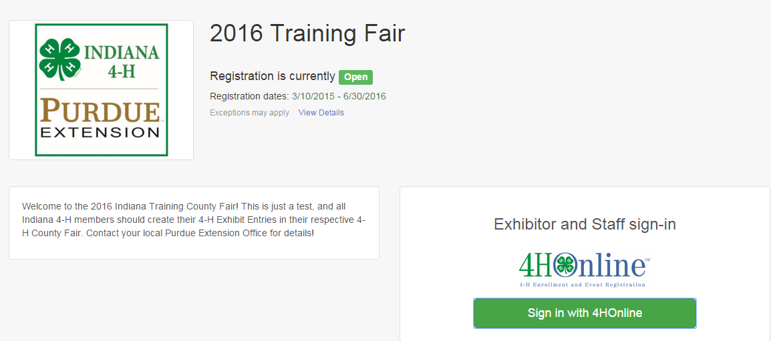
- Select your “Sign in with your 4-H Online account options – the GREEN box

- A separate box will pop up where you can enter the login email address and password from 4HOnline.  (If you don’t remember your password, you will need to select the “I forgot my password” option to get a temporary one emailed to you. If your email address has changed, log in using the old email address and change it in 4HOnline.)  - Click the “Login” box. | 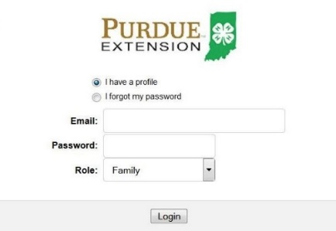
- This will take you to the Welcome screen, where you will need to select the green box to “Begin Registration” | 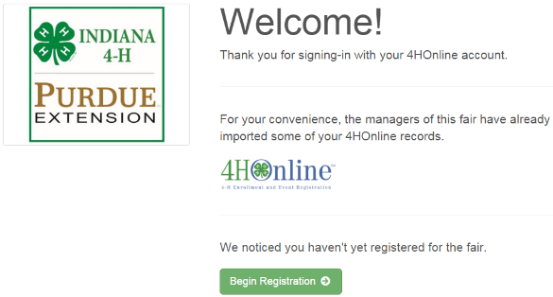
SECTION 1 - EXHIBITORS TAB

- Choose if you would like to register an individual or a team and click that green box | 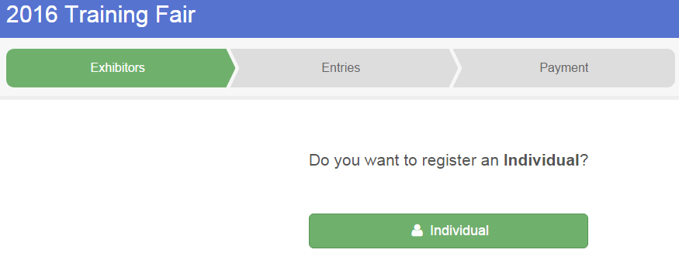
- Choose the dot next to the name of the 4-H’er you would like to register and then click the green “continue” box.  Please do not create any exhibitors from scratch, as you will not be able to add exhibits for the projects you are enrolled in. | 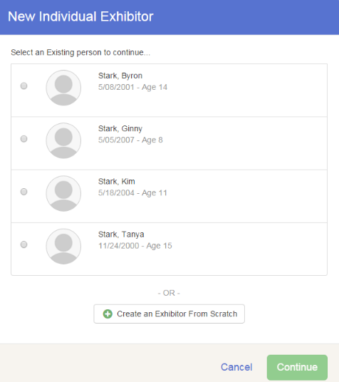
- Answer any required questions and review the exhibitor registration information.  - Make any necessary corrections (using the edit boxes). Remember that any corrections made here DO NOT transfer back to your 4HOnline Account  - If Additional questions are required by your county, complete the questions and then select the green “Continue” box  - When you are taken back to the Exhibitor information page, click the green “Continue to Entries” button | 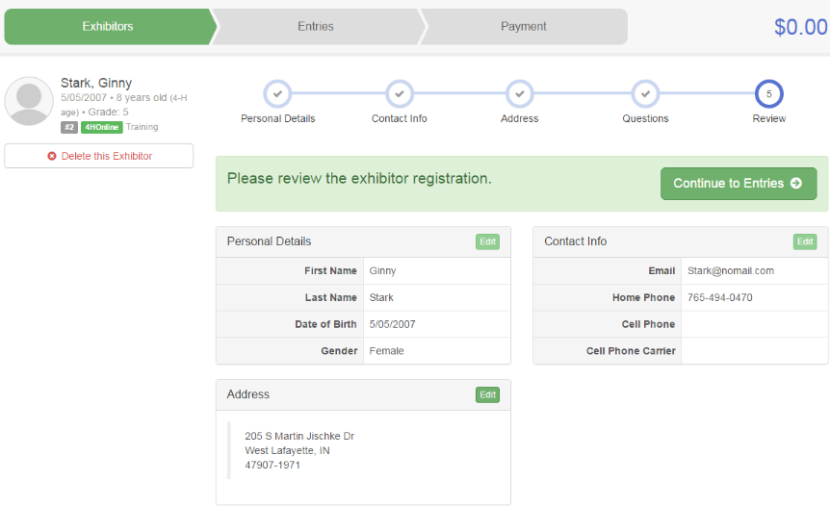  4-Her’s Family address  555-555-5555
SECTION 2 - ENTRIES TAB
- Click the green “Add an Entry” box to the right of the exhibitor’s name  - Click the green “Select” box next to the Department you would like to enter | 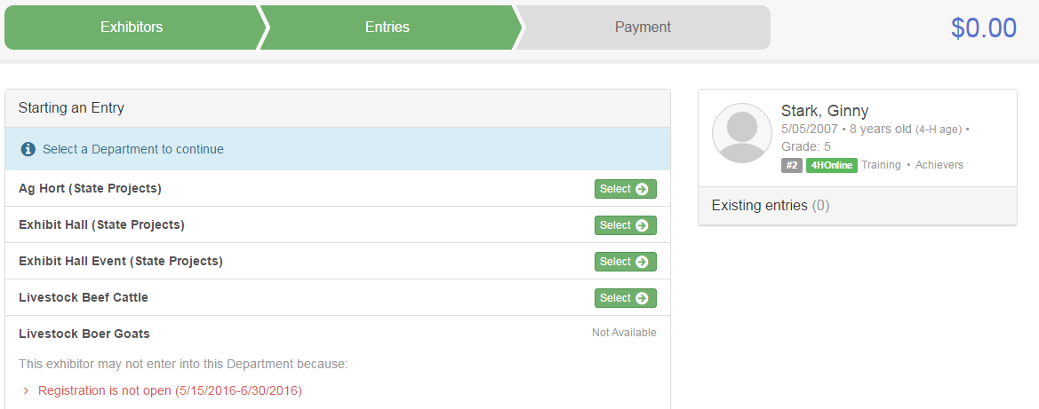
- Click the green “Select” box next to the Division you would like to enter | 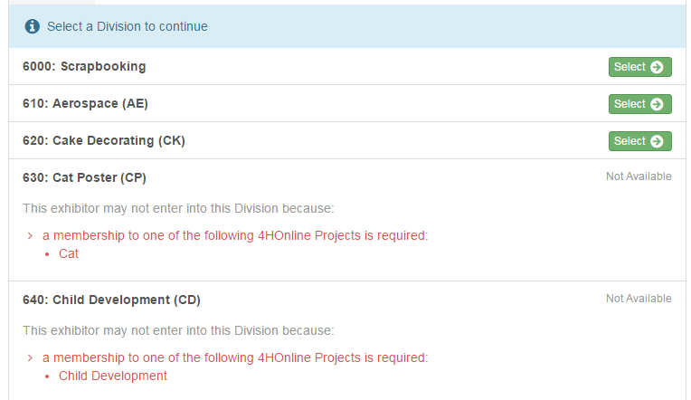
- Click the green “Select” box next to the Class you would like to enter  - Review the selection of the Department, Division and Class. To correct errors in the Department, Division or Class, click the corresponding ‘Change’ button. Click the green ‘Continue’ button to move to the next step.  - Select the dot next to the 4-H Club that you belong to and then select the green “Continue” box | 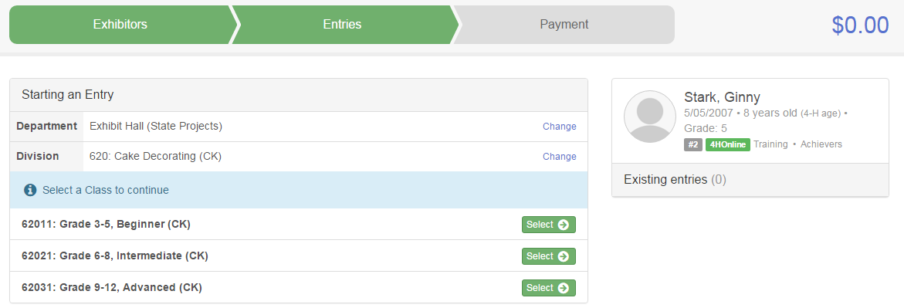  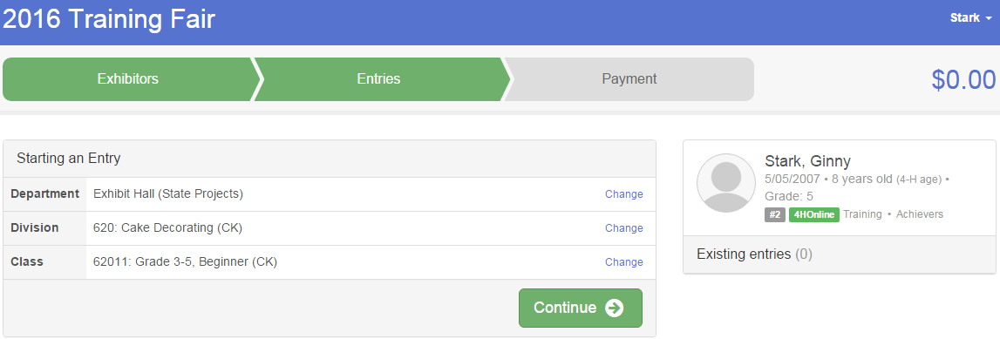  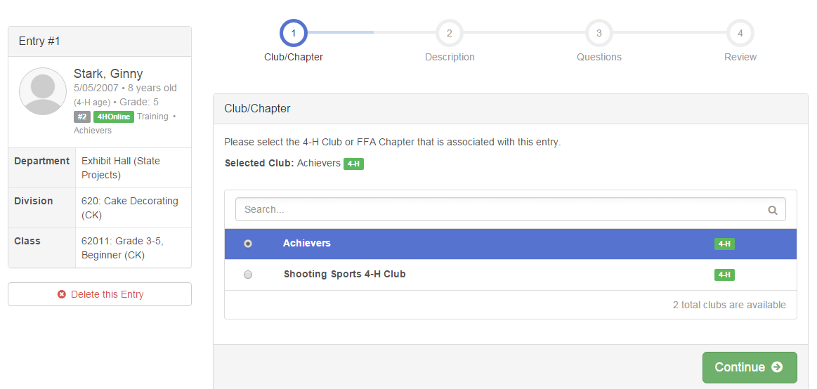
- If required, enter in a description of your exhibit and click Continue– please be specific as this description for non-animal exhibits will be used to distinguish between exhibits, example – don’t just type in “photo”, type in more description, such as “Butterfly on leaf photo” | 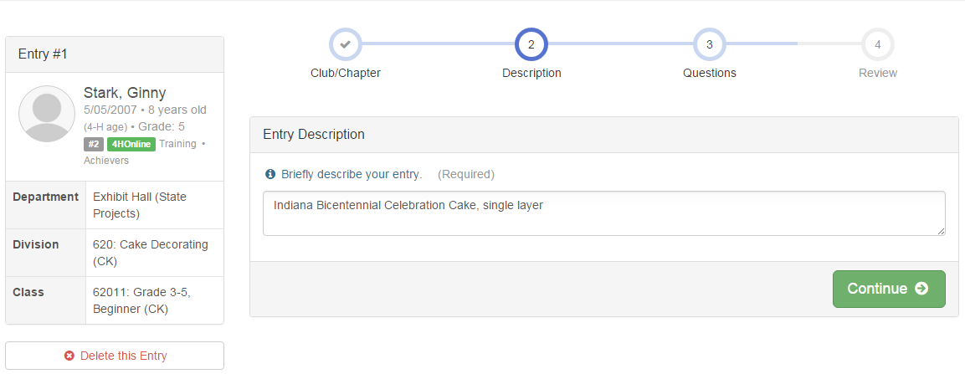
- Answer any Additional Questions required for that entry and then click the green “Continue” box.

- Decide if you would like to:  > Add another Entry  >Add another Entry in this Division  > Register another Exhibitor  >Continue to Payment  and select that appropriate box  ***The payment section is a formality of the system. No payment is needed, but you must go through the steps to submit your entries. | 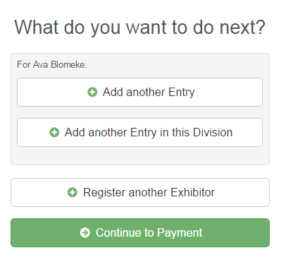
- To register an animal entry from 4HOnline, you will select the white “add an animal” box during the entry process. | 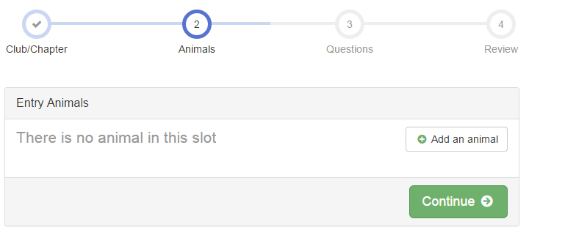
- A smaller box with two options will pop up. Choose the green “Choose an Existing Animal Record” box to enter an animal that was identified in 4HOnline.  To enter a Cat, Dog, Rabbit or Poultry/ Pigeons/Waterfowl animal, please select “Enter a New Animal Record”, and complete all applicable fields on the screen. | 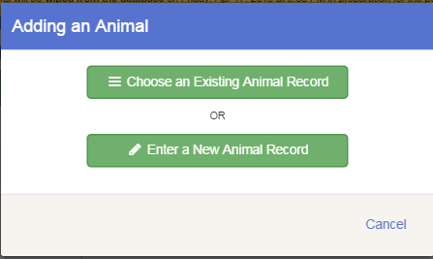
- A list of those animals that you have previously ID’d in 4-H Online that are eligible for that class are listed. Select the circle next to the animal you would like to enter. Then select the green “Select Animal” box. | 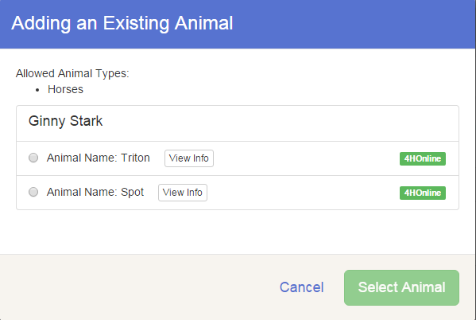
- All of the information about that animal will be pulled over from 4-H Online, so that you can check to make sure that is the correct animal. If you want to switch to a different animal, click on the “remove from entry box”. If it is correct, click the green “Continue” box. Then you will be taken to the Additional Questions page listed in step #20. | 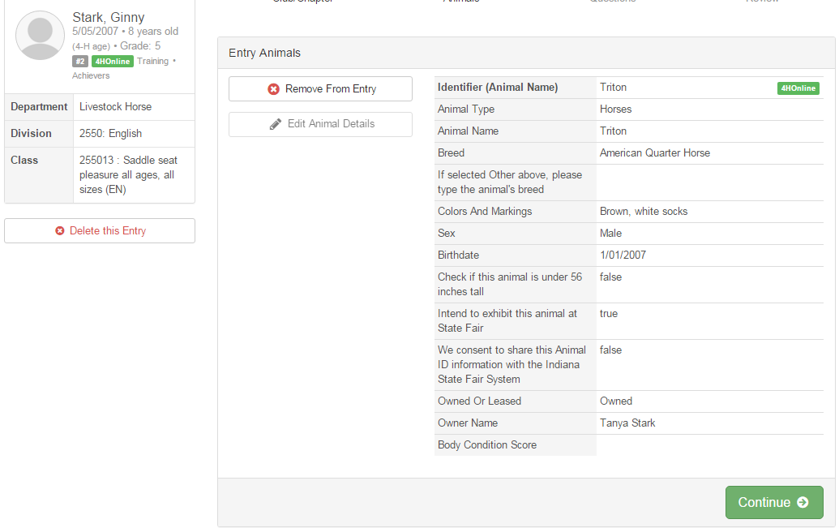
SECTION 3 - PAYMENT TAB
***The payment section is a formality of the system. No payment is needed, but you must go through the steps to submit your entries. It is best to enter all entries for all exhibitors in your family before completing the Payment and submission steps.
- Review your invoice, either in summary format or detail format. If it looks correct, click the green “Continue” box. If not, go back to the entries tab and fix what you need to.  - Select the green “Continue box.  **There are no fees for 4-H exhibits. | 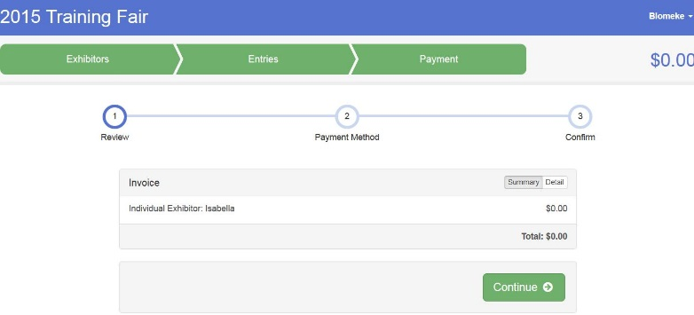
- Confirm your entries one last time. You can see a summary of exhibitors in your family, or their entries in detail. Make sure all entries for each exhibitor in your family are listed before you submit the entries.  NOTE: Once you hit submit, you cannot edit your entries. | 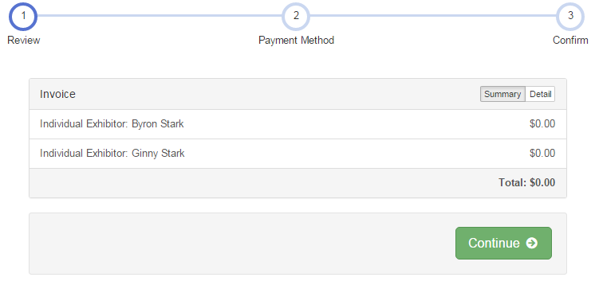
- Click Continue to confirm and submit your entries. | 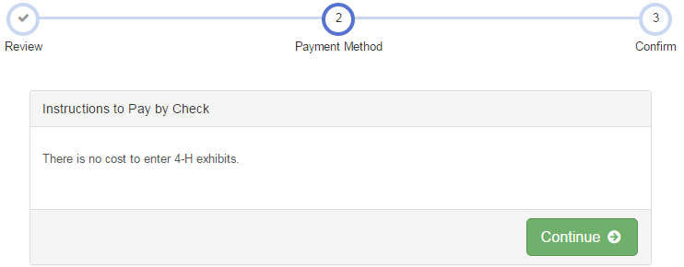
- Click the Submit button to submit your entries. | 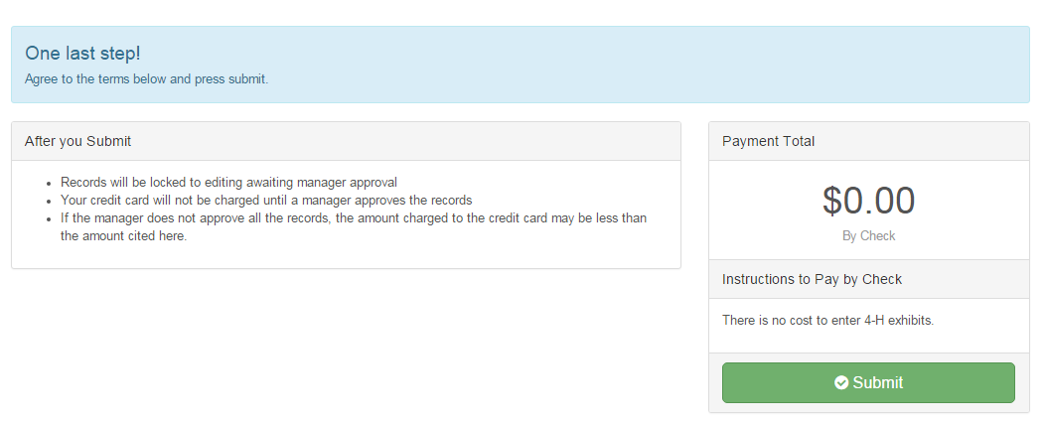
- You will receive a “Thanks!” message. You can choose the button to “Visit Dashboard” to see your entry.

You will receive an email from Fair Entry after your entry has been submitted.
You will also receive an email from Fair Entry letting you know if your entry was approved or rejected by the County Extension Staff. If part of your entry was rejected, a reason will be listed and you will be able to log in and fix the problem before submitting that entry again. Please contact the White County Extension Office if you have any problems with this process at 219-984-5115 or 765-357-8029.

